FSM Lock Counter

Department of Computer Systems Engineering

University of Engineering and Technology, Peshawar

Lab Report # 07



Spring 2020

CSE 308-L—Digital Systems Design--Lab

Submitted by: Muhammad Asif Ayub

Registration No: 17PWCSE1508

Class Section: A

“On my honor, as student of Engineering and Technology, I have neither given nor received unauthorized assistance of this academic work”.

Submitted to:

Engr. Madiha Sher

Thursday, July 9, 2020th

FSM Lock Counter



**Question 1:-**

**Build an electronic combination lock with reset button, two number buttons**

**(0 and 1), and an unlock output. The combination should be “01011”**.

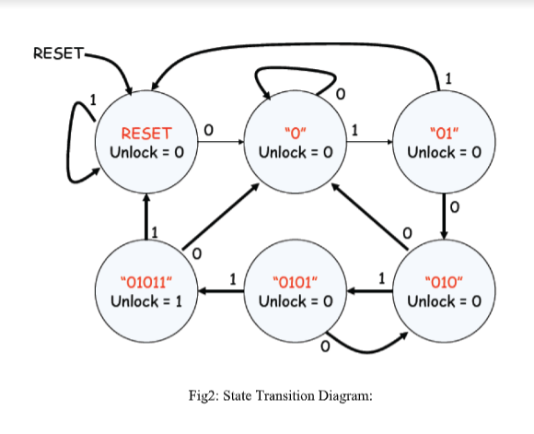

**Main Module:-**

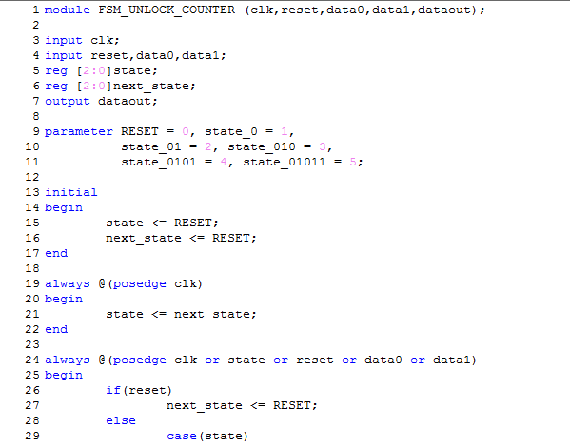

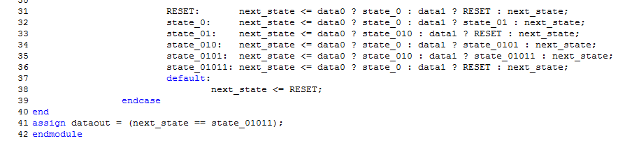

**Top Module:-**

